Information Architecture Design description
1.0 Introduction
This document describes the design of the SMS gateway, how information is to be shared amongst entities involved. It is described in two ways, the High level view and the low level view. The high level view shows the general structure of the system, and how it should generally work from the users to the system. The low level view describes what occurs in each of the entities, how the information received and processed.
It also describes the information storage proceedings, data retrieval and data input. The security aspect is also put into consideration, that is who is authorized to view the data and how much.
2.0 The High Level System Description
The SMS application system is mainly designed for the user to schedule for interactive iLabs but also requires an administrator to configure the application before it is used. An administrator is also may require to review the performance of the application, how the users have sent messages and how the messages have been successfully replied.
2.1 The typical user (student)
The figure below shows the typical process that the user's SMS takes when the application is being used.
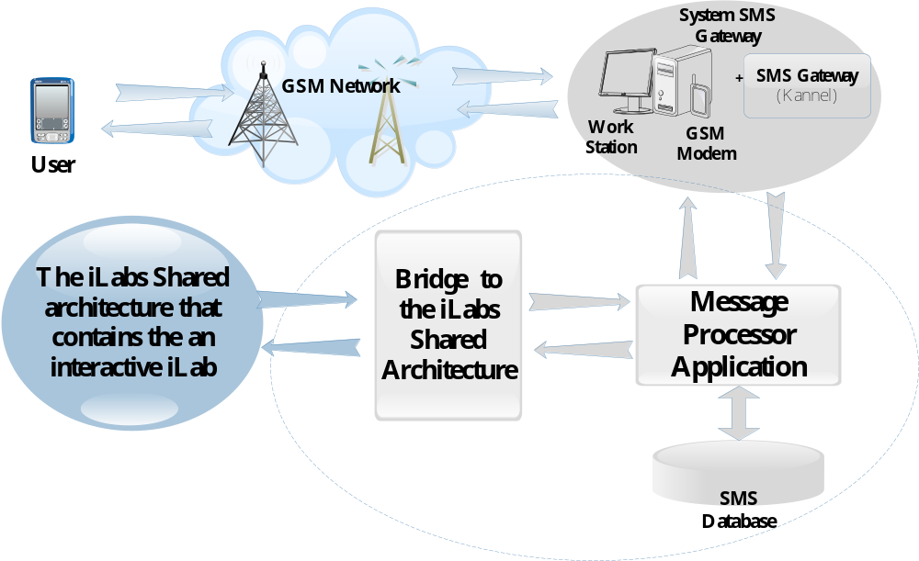
The figure above shows the major entities involved when a typical use, who is a student in this case, is scheduling for an iLab. As shown above, these entities include; a user with a mobile phone, a GSM network, a system SMS Gateway, Message Processor application with a database, Bridge to the iLabs Shared Architecture (ISA) and the ISA itself which contains an interactive iLab.
The entities colored in grey are of major concern in the development of the application and these are the ones we are to build to connect the user with a GSM enabled mobile phone to the ISA.
The entities to be developed seat on two server machines which in this diagram are separated by the oval-shaped figures. The SMS gateway which is developed and configured uses a linux- based server, while the message application and the bridge use their own server, which is a windows based server. The two servers communicate by HTTP post and Get protocols.
The two entities on the windows machine, that is, the bridge to the ISA and the message processor application communicate internally by use of Web Services. Web Services may communicate by open protocols which in this case are Simple Object Access Protocols and the Hyper Text Transfer Protocol (HTTP) (w3schools, 2011).
Observe that the overall system communicates bi- directional. this is shown by use of two allows between each entity meaning that each of the entities replies back to the entity that it communicates with.
2.2 The Administrator
The administrator interacts with the application in two ways, which are configuring the SMS application so as to be used on a particular interactive iLab and viewing the statistical performance of the application for a particular lab.
2.2.1 Lab Configuration
This configuration enables the application to hold data that is required for scheduling any user of the application but is not required to be provided by the user. Such information contains the lab details that the user is scheduling for such as the Service Broker Global Unique Identifier (GUID), the Lab Server GUID, the duration that the student takes to do the lab, and much more.

2.2.2 Statistical Review
The administrator might want to know the technical performance of the application, that is how many user have used the application, if the application has successfully replied the user, how many users have successfully scheduled, how many have not and why they failed to be scheduled.
3.0 Low Level Description of the Application
3.1 Introduction
This section describes the individual entities that are to be developed, showing the purpose of each, how it processes the information it receives and data storage proceedings if any. The processes looked at include the System SMS Gateway, the Message Processor application with database and the Bridge to the ISA.
3.2 The System SMS Gateway

3.3 The Message Processor application with Database
The Message Processor application is the core of the SMS Scheduling System. It contains the web service application which communicates with the SMS gateway and the web site application that is used by the administrator for statistical review and lab configurations.
Below are the functions of the Message Processor Application;
- To the Student, during Scheduling;
- The application receives messages from the SMS gateway which have been sent by the user.
- Splits the message to pick out the user elements that are required by the system to carry out a schedule and ensures that all requirements for scheduling a met.
- Checks if the user is registered with the service broker and is authorized to do the lab that he or she is scheduling for before the actual schedule is carried out.
- Checks if the acronym given by the user is as attached to any of the labs that is configured to be scheduled on line.
- Ensures that the date and time requested by the user is well formatted, up-to-date and is within the time of for the lab to be done.
- Stores the incoming messages that have been sent by the user or student
- Uses the student credentials sent in the message and the configurations set for a given lab to schedule the student by connecting to the ISA Bridge.
- Stores the outgoing messages to the user.
- Formats a message reply to the user concerning the result on the scheduling, if it was a success or failure and why the scheduling failed to occur.
The functions and how they are carried are best described in the figure below;
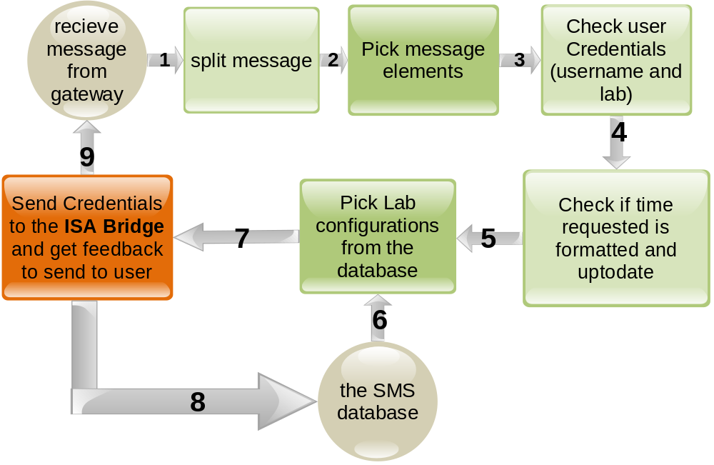
The above figure shows the ideal scheduling process steps that the application takes during scheduling; how the scheduling process works in the Message Processor Entity. The orange rectangular box shows the connection to the ISA Bridge. Each stage above is represented by a method in the application. Also, every stage contains an error check to ensure that the message conditions have been satisfied. If the conditions are not satisfied, the session of the message is terminated at that point.
Whenever termination occurs, whether a user is scheduled successfully or not, the system ensures to reply the user, pointing out whether the scheduling has been a success or not and why the scheduling has not been a success. Also the results session are stored in the database. Some of these include, the incoming message received, the message sent and the user credentials.
Below is a detailed data flow diagram of the message processor;
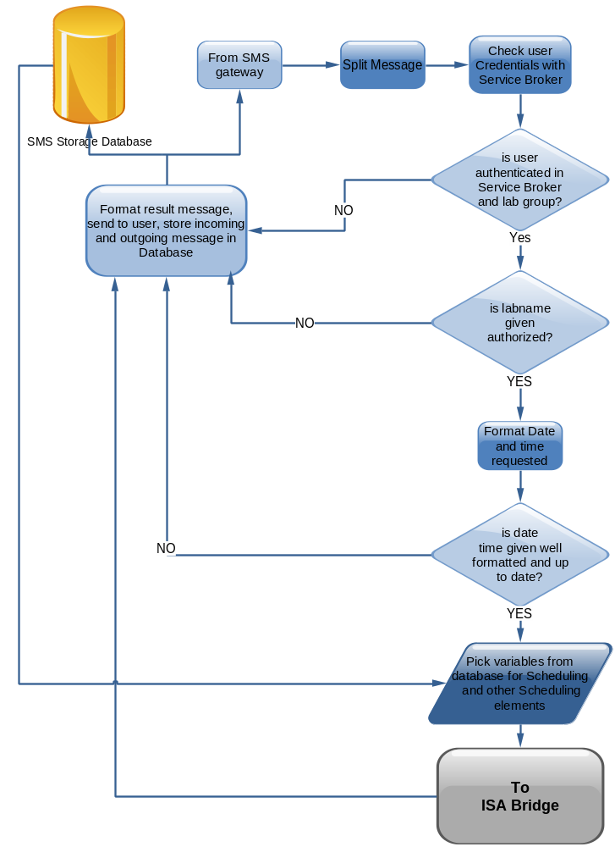
This flow chart shows that the session of application usage is initiated by the student requesting for a schedule through the SMS gateway. The Session is then terminated when the application returns a string message back to the gateway, which then replies the user. The reply message to the student shows if the schedule has been successfully carried out or failed and if failed, what was the cause. The ISA is currently being treated as a black box and will be looked at in the next section.
3.4 The Bridge to the ISA

4.0 The Storage Procedure Modules

